U-shaped Optical Fiber to Determine Characteristics of pH Sensor
Muhammad Yunus

Department of Physics, FMIPA, Gorontalo State University, Gorontalo, Indonesia, 96554
Email : muhammad.yunus@ung.ac.id
Diterima (Tanggal Bulan Tahun), Direvisi (Tanggal Bulan Tahun)
Abstract. Determination of the characteristics of the pH sensor using U-shaped optical fiber was carried out with various varieties, namely length without a coat, indentation diameter, and the number of imperfections. Optical fiber as a light transmission medium is used as a sensor to detect the pH level of the solution. The sensor output is read on the OPM in the form of output power. The best characteristic of the pH sensor was obtained in the number of imperfections, namely number of imperfections 3 with a value range of 32.0 µW, a sensitivity of 3.2 µW/pH, and a resolution of 0.3 x 10⁻³ pH. The greater the power losses in the optical fiber sensor, the better the sensor characteristics. Determination of the characteristics of the pH sensor is very suitable to be carried out using U-shaped optical fiber in simple measurements and easy fabrication.
Keywords: optical fiber, pH, sensor, U-shaped.
Abstrak. Penentuan karakteristik sensor pH menggunakan serat optik bentuk-U dilakukan dengan berbagai variasi, yaitu panjang tanpa jaket, diameter lekukan, dan jumlah pencacatan. Serat optik sebagai media transmisi cahaya digunakan sebagai sensor untuk mendeteksi kadar larutan pH. Hasil keluaran sensor terbaca pada OPM berupa daya keluaran. Karakteristik sensor pH terbaik diperoleh pada variasi jumlah pencacatan yaitu jumlah pencacatan 3 dengan nilai range 32.0 µW, sensitivitas 3.2 µW/pH, dan resolusi 0.3 x 10⁻³ pH. Semakin besar rugi-rugi daya yang terjadi pada sensor serat optik, menghasilkan karakteristik sensor semakin baik. Penentuan karakteristik sensor pH sangat cocok dilakukan menggunakan serat optik bentuk-U pada pengukuran sederhana dan fabrikasi yang mudah.
Kata kunci: serat optik, pH, sensor, bentuk-U.

INTRODUCTION
The technological development of the industrial era 4.0 provides various innovations for measurement and monitoring systems. With technology development, an object can be controlled through remote communication such as information technology. Information technology has a good impact on the development of increasingly sophisticated technology. One example is the optical fiber communication system [1–3]. Optical fiber is a light transmission line consisting of plastic and glass optical fibers. Plastic optical fiber are more elastic and robust than glass optical fiber [4,5].
Currently, optical fiber is one of the trends in sensor-based research. The progress of optical fiber sensor systems is growing because it has high sensitivity and simple structure. Optical fiber has unique properties such as being cheap, light, robust, small size, durable, flexible, corrosion-resistant, and immune to electromagnetic interference [6]. Research-based on fiber optic sensors is increasingly in demand because it can monitor environmental variables such as humidity, turbidity, pressure, temperature, pH, etc. These variables are closely related to the properties of water [7–14].
Water is the primary source of the human need for survival. The critical role of water is to improve environmental health and quality of life. Water can be used in various fields such as fisheries, plantations, animal husbandry, industry, etc. Clean water is needed for proper consumption and daily use. In addition to clean water, polluted water can pose a danger if it enters the body. Contaminated water contains bacteria that can cause disease. One of the diseases caused by consuming polluted water is diarrhea [15,16].
Clean water has a pH standard of 7-8, while drinking water has a pH standard of 6.5-8.5 [15,17]. The pH scale consists of 0 to 14, with the normal pH being 7. pH is the acid or base levels of a solution. A pH value of less than 7 is an acid solution, and a pH value of more than 7 is a base solution [18].
Several studies on water pH, including Akbar, et al have made a prototype to monitor the pH quality of acid water based on the internet of things (IoT). This monitoring uses a pH meter sensor connected to the arduino microcontroller [17]. Sensors connected to a microcontroller to measure the quality of water pH have also been carried out by Reski, et al [19]. The water acid test uses a pH sensor, a galvanic pH sensor, and a plastic optical fiber-based pH sensor testing using a UV-cured-sensitive hydrogel. Some of these tests were carried out without determining the sensor characteristics, such as the sensitivity value [20–22]. Another development is testing the pH sensor using optical fiber, which is bent to form a loop configuration using a microcontroller which has the disadvantage of complicated fabrication [18,23]. Thus, the innovation of this research will be testing a fiber optic-based pH sensor. The optical fiber is bent into a U-shaped groove to determine the characteristics of the pH sensor for simple measurements and easy fabrication.
RESEARCH METHODOLOGY
This research uses a plastic optical fiber type polymethyl methacrylate (PMMA). This type of optical fiber consists of 3 structures: coat, cladding, and core. A coat is 2.2 mm, cladding is 1 mm, and core is 0.98. Optical fiber mounted on an IF-E91A type infrared LED light source. The LED light activated by the power supply will be transmitted into the optical fiber and received by a photodetector type S120 C. The photodetector is connected to an Optical Power Meter (OPM) Thorlabs PM100D type. The sensor output power value will appear on the OPM. The pH solution used is a buffer solution with pH levels of 1-10. The design of the U-shaped optical fiber pH sensor is shown in Figure 1, and the schematic of the pH sensor is shown in Figure 2.
LED

Photodetector

Holding sensor
Optical fiber

Optical fiber without coat
Diameter
Imperfection

Figure 1. Design of U-shaped optical fiber-based pH sensor.

A schematic of U-shaped optical fiber to determine the characteristics of the pH sensor shown in Figure 2. Optical fiber as a light transmission medium is used as a sensor. Testing the sensor is immersed in the pH solution to detect the levels of the pH solution.

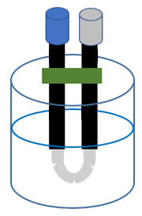

OPM
Power suplay

pH solution

Figure 2. Schematic of U-shaped optical fiber-based pH sensor

The photodetector will receive the LED light transmitted into the optical fiber. The light received by the photodetector is in the form of power losses which will be read on the OPM. The sensor output is read on the OPM in the form of sensor output power. The sensor output power is then analyzed to determine the sensor characteristics using the equations, namely range (1), sensitivity (2), and resolution (3) [2,4].

$∆P=P_{max}-P_{min}$ (1)
$S=\frac{P_{max}-P_{min}}{K_{max}-K_{min}}$ (2)

$R=\frac{N}{S}$ (3)

∆P is the range (µW), P_{max} is the maximum output power (µW), P_{min} is the minimum output power (µW). S is the sensitivity (µW/pH), K_{max} is the concentration of the maximum pH solution (pH), K_{min} is the concentration of the minimum pH solution (pH). While R is the resolution (pH), and N is the smallest scale value of OPM 0.001 µW
RESULTS AND DISCUSSION
Determination of the characteristics of the pH sensor based on U-shaped plastic optical fiber is carried out without a coat on the optical fiber. Testing of the pH sensor with various varieties, namely length without coat, diameter, and the number of imperfections. This method is carried out to determine the characteristics of the best pH sensor.
The optical fiber is peeled on the coat with various varieties of 1 cm, 2 cm, and 3 cm at a fixed diameter of 3 cm. The results of testing the length without coat variety can be seen in Figure 3.

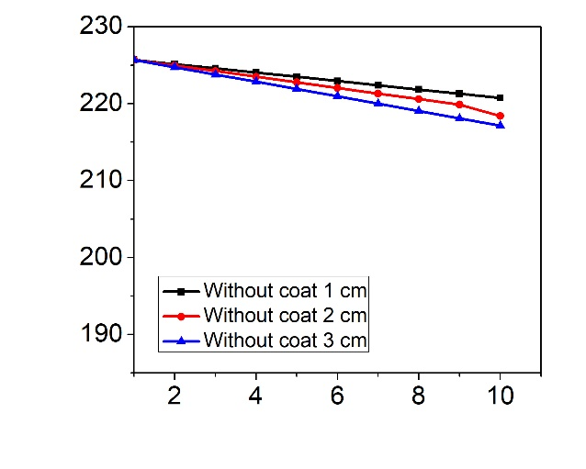
Output Power (µW)
pH Solution (pH)
Figure 3. Graph of sensor output power on length without coat variety.

Figure 3 shows a graph of the output power of the pH sensor at length without coat variety. The greater the value of the given pH solution, the smaller the sensor output power value. The increasing pH value of the solution causes the refractive index of the pH solution to increase. The increasing refractive index of the solution causes power losses to the sensor to increase so that the sensor output power value that is read on the OPM decreases. [4]. Figure 3 shows that a sensor of the length without a coat at 3 cm has significant power losses. The longer without a coat, the greater the power losses that occur [3].
Next, we tested a U-shaped pH sensor with indentation diameter variety at a fixed length without a coat of 3 cm. Indentation diameter variety will give 1 cm, 2 cm, and 3 cm. The results of testing the pH sensor for indentation diameter variety can be seen in Figure 4.

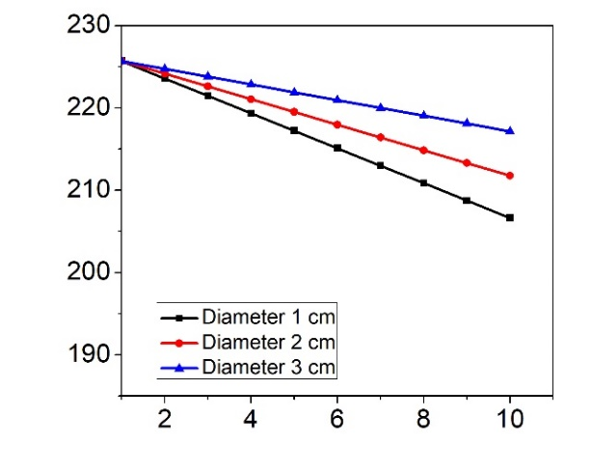
pH Solution (pH)
Output Power (µW)

Figure 4. Graph of sensor output power on indentation diameter variety.

Figure 4 shows the results of the sensor output power on the indentation diameter variety to measure the pH solution. The increasing value of the pH solution causes the sensor output power value to decrease. The value of the pH solution increases, and the refractive index of the pH solution also increases [18]. The increasing refractive index causes the power losses in the sensor to increase so that the sensor output power decreases [12]. Figure 4 shows indentation diameter of 1 cm has the most significant power losses. The smaller the indentation diameter of the sensor causes the power losses to increase so that the output power decreases [3].
The optical fiber-based pH sensor was tested using the U-shaped method, followed by the number of imperfections. The number of imperfections given is imperfection 0, imperfection 1, imperfection 2, and imperfection 3. This method is carried out on a fixed-length without a coat of 3 cm and a fixed indentation diameter of 1 cm. The results of testing the sensor for the number of imperfections variety can be seen in Figure 5.

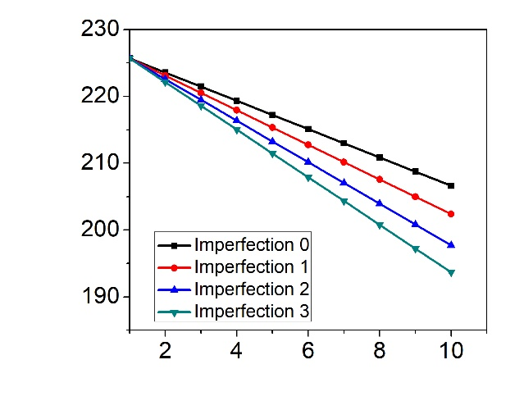
pH Solution (pH)
Output Power (µW)

Figure 5. Graph of sensor output power on the number of imperfections variety.

The graph of the sensor output power for the number of imperfections variety is shown in Figure 5. An increasing pH value results in a decrease in sensor output power. The greater the number of imperfections used in testing the pH sensor, the lower the sensor output power value. This incident is caused because the light transmitted into the optical fiber is released from the defective optical fiber, so the power losses that occur are increasing [5]. Figure 5 shows imperfection 3 has the most significant power losses.
Furthermore, the determination of the characteristics of the optical fiber-based pH sensor uses the U-shaped variety of the length without a coat, indentation diameter, and the number of imperfections. Sensor characteristics determined using equations (1), (2), and (3) are shown in Table 1.

Table 1. Characteristics of pH sensor using U-shaped optical fiber
Characteristics of pH sensor | Without coat variety |  |  | Indentation diameter variety |  |  | Number of imperfection variety
Characteristics of pH sensor | 1 | 2 | 3 | 1 | 2 | 3 | 0 | 1 | 2 | 3
∆P (µW) | 4.9 | 7.3 | 8.5 | 19.1 | 13.9 | 8.5 | 19.1 | 23.3 | 27.9 | 32.0
S (µW/pH) | 0.5 | 0.7 | 0.8 | 1.9 | 1.4 | 0.9 | 1.9 | 2.3 | 2.8 | 3.2
R x10⁻³ (pH) | 2.0 | 1.3 | 1.1 | 0.5 | 0.7 | 1.1 | 0.5 | 0.4 | 0.3 | 0.3

Table 1 shows the pH sensor variety of lengths without a coat, indentation diameter, and the number of imperfections. High range, high sensitivity, and low resolution determine the best sensor characteristics. The best sensor characteristics in length without a coat is 3 cm with a value range of 8.5 µW, a sensitivity of 0.8 µW/pH, and a resolution of 1.1 x 10⁻³ pH. The increasing length without coat optical fiber results in better sensor characteristics. The best sensor characteristic in an indentation diameter is 1 cm with a value range of 19.1 µW, a sensitivity of 1.9 µW/pH, and a resolution of 0.5 x 10⁻³ pH. Meanwhile, the best sensor characteristics of the number of imperfections variety is imperfection 3, with a value range of 32.0 µW, a sensitivity of 3.2 µW/pH, and a resolution of 0.3 x 10⁻³ pH. The greater the power losses in the fiber optic sensor, the better the sensor characteristics [5,18]. The best characteristics of pH sensors in various variety obtained in the number of imperfections, namely the number of imperfections 3. U-shaped optical fiber is very suitable for determining the characteristics of pH sensors in simple measurements and easy fabrication.
CONCLUSION
Determination of the best characteristics of the pH sensor obtained in the number of imperfections variety, namely number of imperfections 3 with a value range of 32.0 µW, a sensitivity of 3.2 µW/pH, and a resolution of 0.3 x 10⁻³ pH. The greater the power losses in the optical fiber sensor, the better the sensor characteristics. Determination of the characteristics of the pH sensor is very suitable to be carried out using U-shaped optical fiber in simple measurements and easy fabrication.
REFERENCES
[1] Junaidi et al., “Measurement of Physical Parameters of Water Quality in Real-Time Based on Arduino”, J. Phys. Conf. Ser., vol. 1751, no. 1, 2021.
[2] M. Yunus, A. Arifin, N. Fuadi, and A. M. Syafar, “Sensitivity Enhancing of Oil Viscosity Sensor Based on Optical Fiber by Using Bending Angle Method”, INTEK J. Penelit., vol. 8, no. 1, p. 43, 2021.
[3] M. Yunus and A. Arifin, “Design of Oil Viscosity Sensor Based on Plastic Optical Fiber”, J. Phys. Conf. Ser., vol. 979, no. 1, 2018.
[4] M. Yunus and A. Arifin, “Karakterisasi Sensor Kekentalan Oli Berbasis Serat Optik Plastik Menggunakan Metode Back Scattering”, Positron, vol. 8, no. 1, 2018.
[5] A. Arifin et al., “Bent of Plastic Optical Fiber With Structural Imperfections for Displacement Sensor”, Indian J. Pure Appl. Phys., vol. 52, no. 8, pp. 520–524, 2014.
[6] Z. Gong et al., “A Taper-in-Taper Structured Interferometric Optical Fiber Sensor for Cu²⁺ ion Detection”, 2022.
[7] P. Vitor, T. De Carvalho, M. Aparecida, and G. Martinez, “Performance Analysis of Humidity Tapered Optical Fiber Sensor”, pp. 0–13, 2022.
[8] Z. Wang et al., “Fiber Core-Offset Humidity Sensor Based on Graphene Oxide Characteristics”, IEEE Photonics J., vol. 13, no. 3, 2021.
[9] D. P. Duarte, R. N. Nogueira, and L. Bilro, “Turbidity and RI dependency of a polymer optical fiber-based chromatic sensor”, Sensors (Switzerland), vol. 20, no. 1, 2020.
[10] É. Pinet, “Pressure Measurement with Fiber-Optic Sensors: Commercial Technologies and Applications”, 21st Int. Conf. Opt. Fiber Sensors, vol. 7753, 2011.
[11] N. Zhao et al., “Research on the High Temperature and High Pressure Gold-Plated Fiber Grating Dual-Parameter Sensing Measurement System”, Micromachines, vol. 13, no. 2, 2022.
[12] A. Arifin, I. Irwan, B. Abdullah, and D. Tahir, “Design of sensor water turbidity based on polymer optical fiber”, ISSIMM-2017, vol. 2017, pp. 146–149, 2017.
[13] D. Razo-Medina, E. Alvarado-Méndez, and M. Trejo-Durán, “Plastic Optical Fiber with Sol-gel Film for pH Detection”, Procedia Technol., vol. 27, pp. 271–273, 2017.
[14] Y. Ran et al., “A Miniature pH Probe Using Functional Microfiber Bragg Grating”, Optics, vol. 1, no. 2, pp. 202–212, 2020.
[15] Y. Adityas, M. Ahmad, M. Khamim, K. Sofi, and S. R. Riady, “Water Quality Monitoring System with Parameter of pH, Temperature, Turbidity, and Salinity Based on Internet of Things”, JISA, vol. 4, no. 2, pp. 138–143, 2021.
[16] Y. Irawan, A. Febriani, R. Wahyuni, and Y. Devis, “Water Quality Measurement and Filtering Tools Using Arduino Uno, PH Sensor and TDS Meter Sensor”, J. Robot. Control, vol. 2, no. 5, pp. 357–362, 2021.
[17] R. S. Akbar et al., “Monitoring Kualitas pH Air Asam Pada Aliran Air Pdam Menggunakan pH Meter Sensor Berbasis Internet Of Things”, vol. 2, pp. 102–107, 2021.
[18] A. Arifin, Hardianti, M. Yunus, and S. Dewang, “Application of Plastic Optical Fiber Material as Ph Measurement Sensor Using Loop Configuration”, J. Phys. Conf. Ser., vol. 1317, no. 1, 2019.
[19] Rezki, B. S. Nugroho, Nurhasanah, “Rancang Bangun Alat Ukur Kualitas Air Berdasarkan pH Air dan Kekeruhan”, vol. 9, no. 3, pp. 297–303, 2021.
[20] J. Karangan, B. Sugeng, and S. Sulardi, “Uji Keasaman Air dengan Alat Sensor pH Di STT Migas Balikpapan”, J. Kacapuri J. Keilmuan Tek. Sipil, vol. 2, no. 1, p. 65, 2019.
[21] M. S. Yuzhakov, D. I. Filchenko, A. V. Badin, and A. K. Berzin, “Galvanic pH Sensor for Continuous Monitoring of Soil Parameters in Agriculture”, J. Phys. Conf. Ser., vol. 2140, no. 1, 2021.
[22] X. C. Heng, J. B. Onefacino, B. O. G. Uan, and H. Y. T. Am, “All-Polymer Fiber-Optic pH Sensor”, vol. 26, no. 11, pp. 14610–14616, 2018.
[23] Z. Tang et al., “A U-Shape Fibre-Optic pH Sensor Based on Hydrogen Bonding of Ethyl Cellulose with a Sol-Gel Matrix”, J. Light. Technol., vol. 39, no. 5, pp. 1557–1564, 2021.

